**1-3.Breathing light on body of robot**

**1.Preparation**

1.You should learn about the position of the colorful lights in the body of hellobot；

2.You should learn about the micro:bit pins connected to the colorful lights in the schematic.

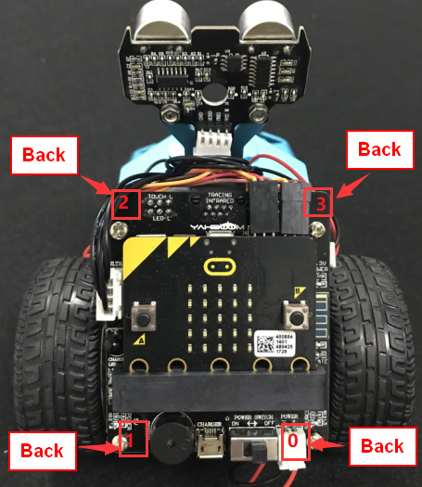

1-3-1 colorful lights on body of hellobot（back）

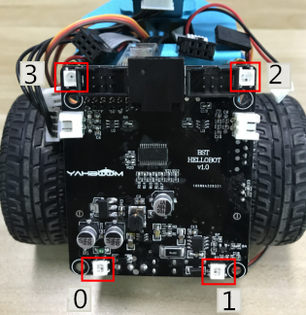

1-3-2 colorful lights on body of hellobot

We can make different colors of light and brightness by programming.

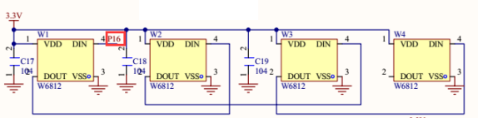

1-3-3 schematic

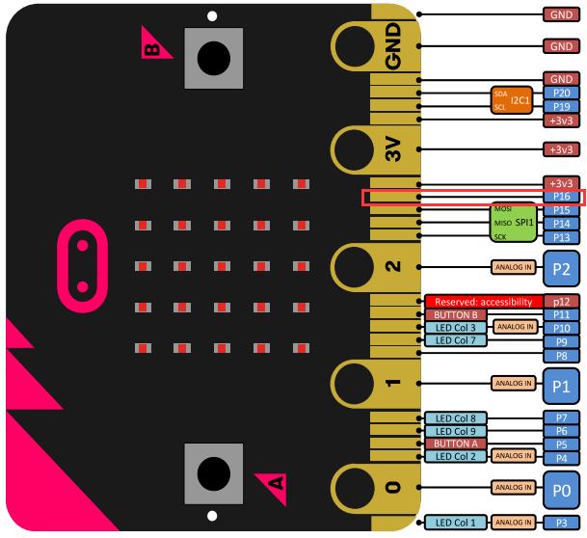

1-3-4 Pins of Micro:bit

From the schematic diagram in P1-3-3, you can see that the colorful lights is connected to the P16 of the Micro:bit.

Note:In the bottom layer of the HelloBot package has been set parameter for the user, you can directly drag the colorful lights building blocks.

1. **Learning goals**

In this course, we learns the new game of colorful lamps - breathing lights. Breathing light: the colorful lamps are changed gradually from light to dark by the control of the micro:bit. It feels like a person is breathing.

**3.Programming**

3.1 Programming online

**1) You should use the USB cable to connect the micro:bit to the computer, at this point, the computer will have a micro:bit U disk. You need to open it, click micro:bit website, then entered the micro:bit website** or you can enter the URL directly in your browser: http://microbit.org/

2) After entering the programming interface, you need to click Add package and copy the HelloBot package URL: https://github.com/lzty634158/HelloBot to the input field, click to confirm the add package. Then you can use the blocks of the HelloBot package.

3.2 Programming offline

1) You can double-click to use it. As shown in the following figure.

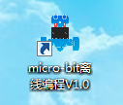

2) After entering the programming interface, you need to click Add package and copy the HelloBot package URL: https://github.com/lzty634158/HelloBot to the input field, click to confirm the add package. Then you can use the blocks of the HelloBot package.

**Note: The package only needs to be added once. If you have added packages in the previous lessons, this course does not need to be added repeatedly.**

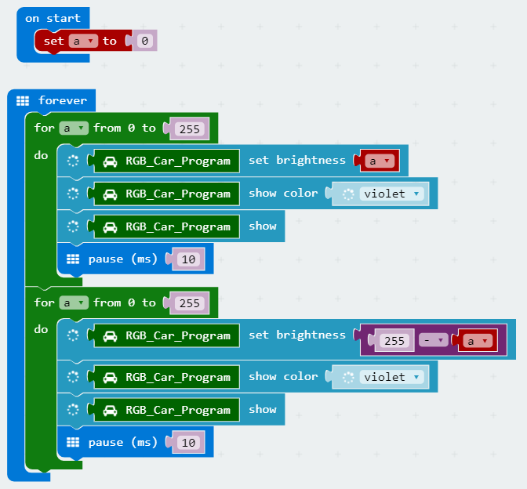

1-3-5 total program

The locations of blocks in the total program are shown in the following figure.

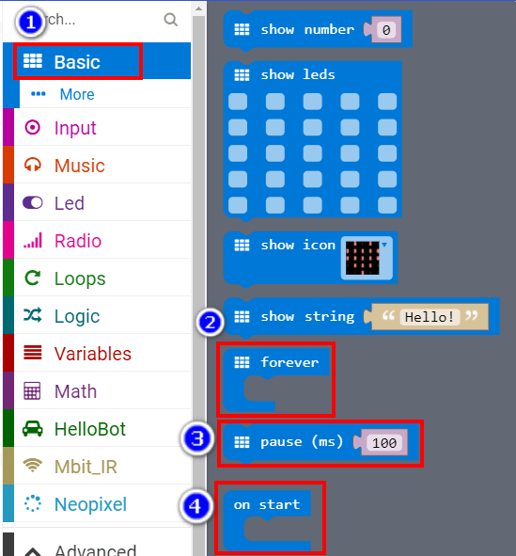

1-3-6

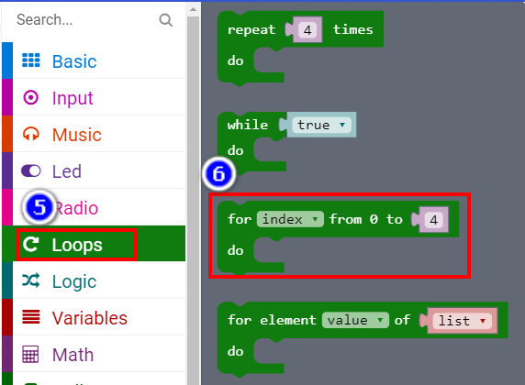

1-3-7

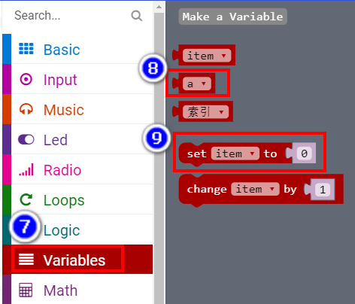

1-3-8

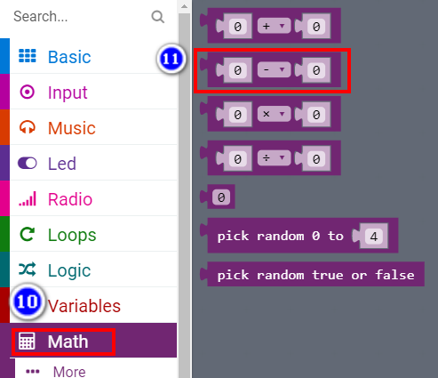

1-3-9

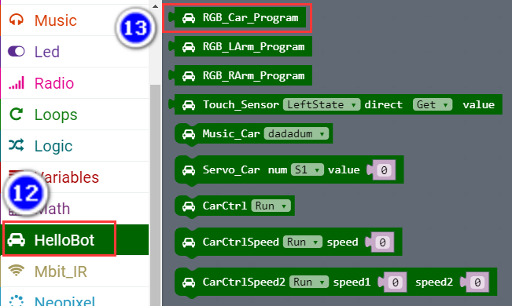

1-3-10

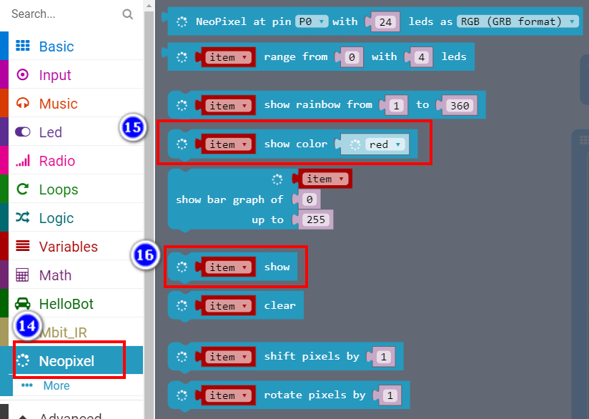

1-3-11

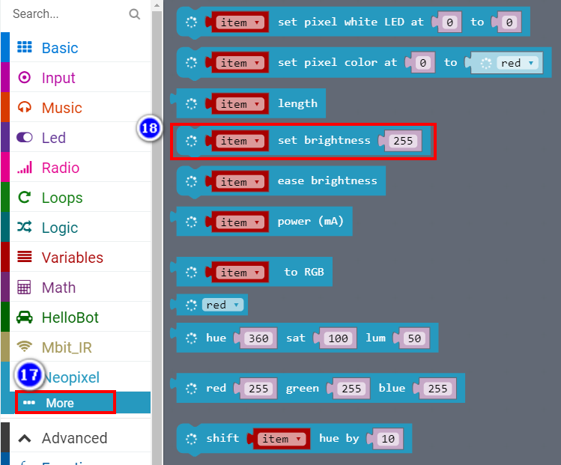

1-3-12

**4.Download programming**

You need to make sure that the micro:bit development board is connected to the computer. Then you should click on the download in the lower left corner as shown in P 1-3-13 to download the program to micro:bit.

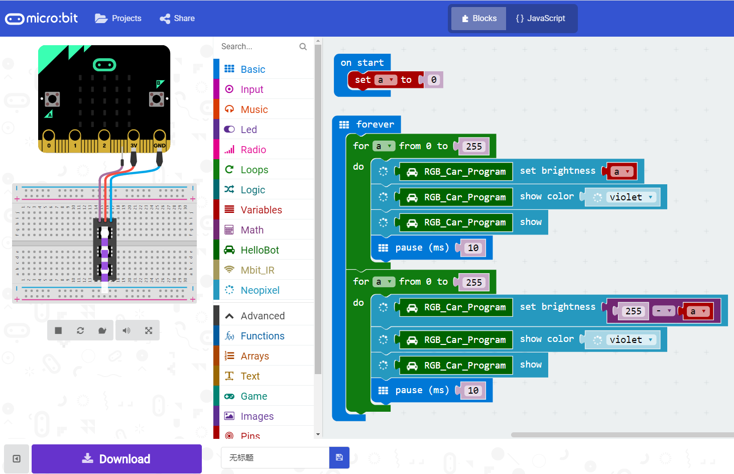

1-3-13

**5.Phenomenon**

After the code is uploaded. You can see that the colorful lamps of robot are changed gradually from light to dark by the control of the micro:bit. It feels like a person is breathing. As shown in the following figure.

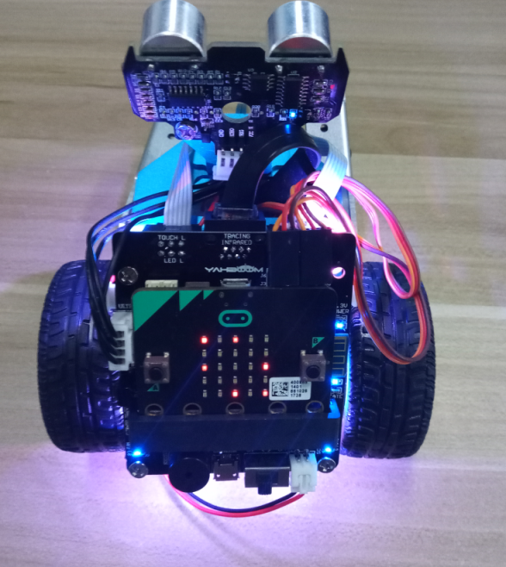 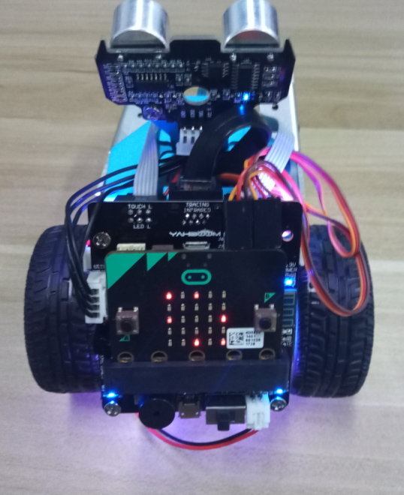

1. (b)

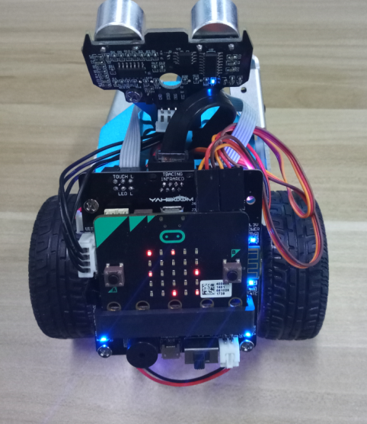 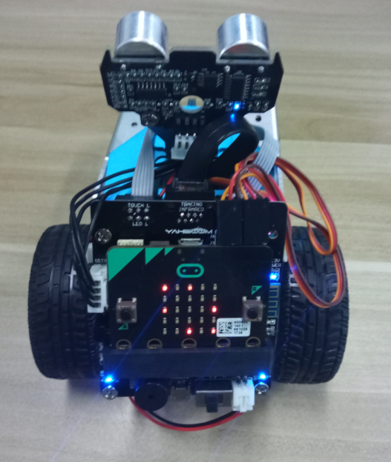

(c) (d)

1-3-14